Pilgrimage to Santiago de Compostela

‘Seven Crowning Stars’

Tuesday 16th May 2023 – Wednesday 24th May 2023

Led by Peter and Sarah Dawkins and Jonathan Tod
The purpose of this pilgrimage is to explore, learn about, enjoy and enhance a magical landscape temple in Galicia. This is a unique journey to Santiago de Compostela. Besides visiting some of the places well known to pilgrims on the Camino, we will divert from the main Camino (the French Way) and go north to the coast and part-encircle Santiago de Compostela, before ending up there. In this way we will visit the ‘Seven Stars’ of the crown chakra of Europe.
Europe takes its name from the classical myth of Europa and the Bull, and mainland Europe can be seen imaginatively as a ‘bull’, with the British Isles seated on its neck as ‘Europa’. Spain and Portugal comprise the head of the ‘bull’. Santiago de Compostela focuses the crown chakra of the ‘bull’.
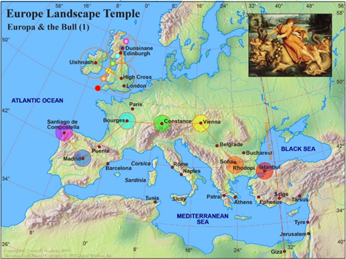
We (Peter and Sarah, Jonathan and Tara) have discovered a sequence of major landscape chakras (centres of energy) which are marked energetically by seven great ‘six-pointed’ stars, which has inspired and dictated the design of this journey. Interestingly, the journey follows a shape which is similar to the shape of an Egyptian Adze, the tool used in the mummification process by the Ancient Egyptians to ‘open the mouth’ of the pharaoh’s ascended soul, so that he can speak the truth or Word of God and thereby help those incarnate on earth. The Adze is patterned on and represents the constellation of Ursa Major, the Great Bear, home of the Seven Rishis.
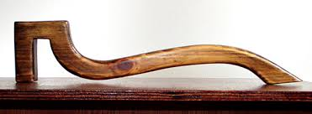
We will be travelling by coach from Bilbao to Burgos, Castrojeriz, León, Astorga, El Cruz e Ferro, Ponferrada, Villafranca del Bierzo, Lugo, A Coruna, Muxia, Finisterre, and Santiago de Compostela.
This pilgrimage relates closely to our earlier pilgrimages in Portugal, as the journey includes the higher crown chakras of the three Portuguese ‘Great Pillars’, which are at Ponferrada, Lugo and Santiago de Compostela.
We are making this journey as a pilgrimage, in the sense of honouring the places by greeting, appreciating and enjoying them, their people and each other. We have two principles which we endeavour as a group to fulfil, which are to make the effort to love who we are with, wherever we are and whatever we are doing, and to do the right thing, in the right place, at the right time, and with the right intention. In this way we can enhance the places and the whole landscape temple, enthusing it with love and thereby helping to transform the planetary energies into ethereal ‘light’. In such ways we help to build the ‘light body’ of the planet, which in turn affects consciousness everywhere in beneficial ways.
In addition, by pilgrimaging in this way within the Bull of Europe, we can help Europe to metaphorically breathe its physical breath in conjunction with its spiritual breath (inspiration). Taurus, the Bull, is associated with the throat chakra; Europa is associated with the alta-major chakra. The former is represented by mainland Europe, the latter by the British Isles. The former is the gateway for the physical breath, the latter for the spiritual breath. The two breaths, breathing in harmony, are what the world needs, and what each pilgrim can perform as an act of loving service.

Itinerary Highlights
Tuesday 16th May – arrive at the Hotel Ercilla Lopez de Haro in Bilbao [well situated in the centre of Bilbao], 5 minutes’ walk across the bridge to the Old Quarter; welcome meeting followed by dinner.
Wednesday 17th May – After a morning meeting and lunch, we will go out into Bilbao visiting some of the main sites. There will be an opportunity in the afternoon to visit the world-famous Guggenheim Museum. The city’s Old Quarter and the Museum are both within walking distance of the hotel. Late afternoon, we will visit ‘as pilgrims’ the cathedral dedicated to St James and make our dedications for the journey. Dinner and overnight at the Hotel Ercilla Lopez de Haro.
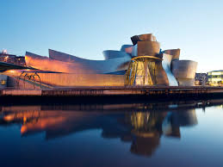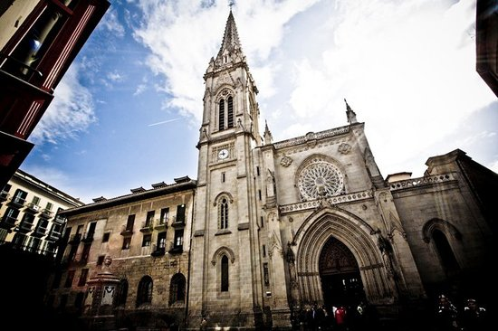
Thursday 18th May – After breakfast, we will set off by air-conditioned coach to Burgos, which is an important stopping point on the French Camino to Santiago de Compostela. We will visit the vast cathedral and have a lunch of local speciality dishes. In the afternoon we will visit the Templar church in Castrojeriz and travel on to Leon. We will stay at the Plaza Mayor at the NH Collection Hotel Plaza Mayor, which is the main square in the middle of the old town.
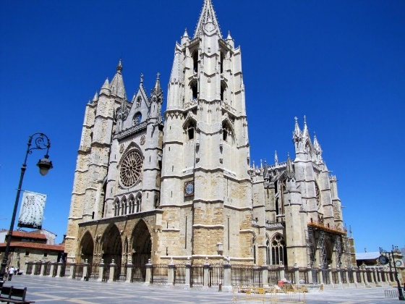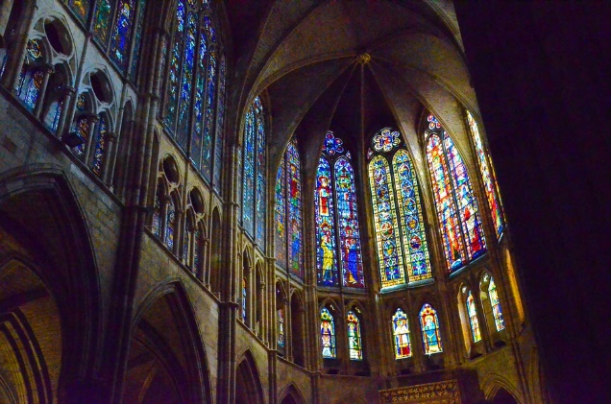
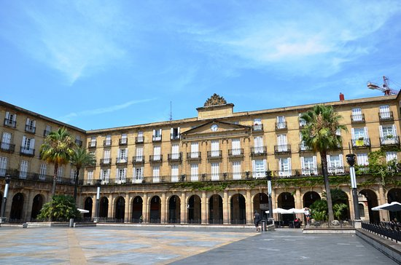
Friday 19th May – After Paneurhythmy (for those that want to) and breakfast, we will visit the important sites in Leon, spending time in the cathedral and the Plaza Major, and enjoying a coffee break in one its historic streets. Afterwards we will travel on to Astorga, which is at the north end of the Via de la Plata, which is the camino which brings pilgrims from southern Spain. Here pilgrims meet the French Way and turn westwards to complete their journey. We will have lunch before visiting the cathedral. We will spend time here working on the ‘hidden star’, and stay overnight.
Saturday 20th May – After Paneurhythmy and breakfast, we will travel to El Cruz e Ferro, which is an ancient mound of stones and rocks brought by pilgrims from their homes to this place. In accordance with tradition, with our backs to the mound, we will throw stones which we will each bring from our homes over our shoulder, symbolically marking this journey away from home to adventure into the world for higher purpose.
We will then move on to Ponferrada, and visit the Basilica dedicated to St Mary and the 12th century Templar Castle. These sites are steeped in learning and, we believe, formed the base for a great mystery school to which early aspirants and later Templar knights were sent to learn and train for a life beyond the mundane. This is the higher crown chakra of the left-hand pillar – the left-hand pillar being associated with Divine Intelligence and understanding. We will spend the remainder of the day here and stay overnight at the Hotel Ponferrada Plaza.
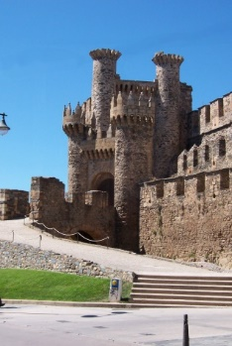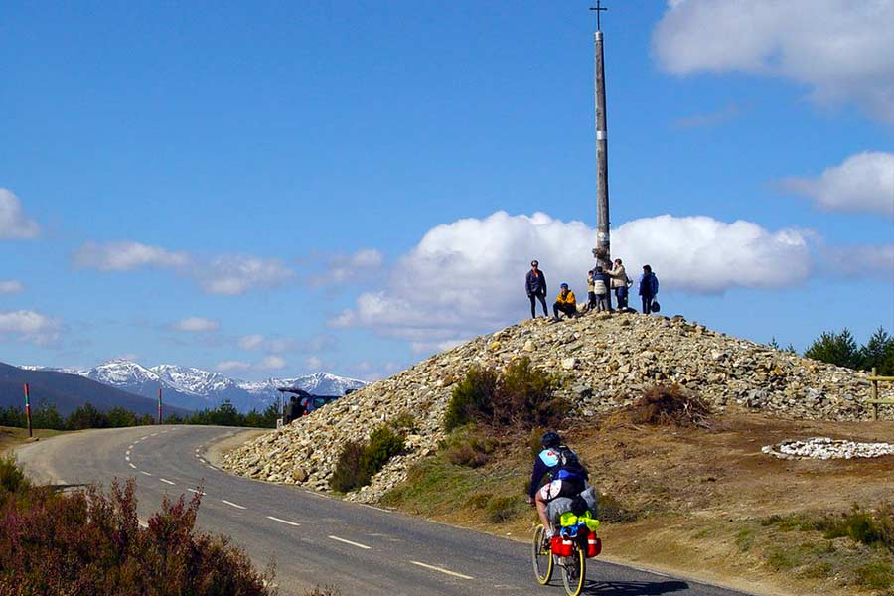
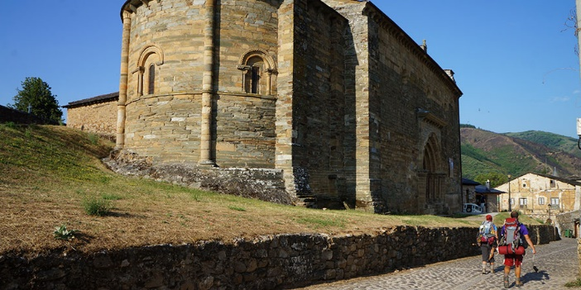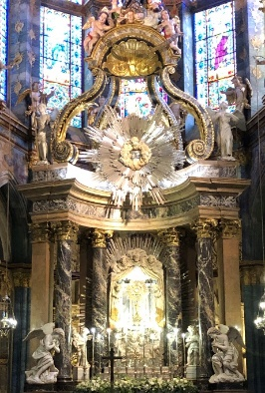
Sunday 21st May – After Paneurhythmy and breakfast, we will travel on to the Church of Santiago in Villafranca del Bierzo. The north-facing doorway is known as ‘the Gateway to Forgiveness’. A 12th century pope allowed the sick and ailing to be deemed to have completed their pilgrimage here, prior to the climb up the mountains of Galicia. This was allowed in exceptional circumstances and only in a holy year. This is a gateway to the sacred lands of Galicia. Shortly after this stop, we will divert north, away from the French camino, and head for Lugo. We will arrive in time for an attunement together on the town’s walls near the cathedral before lunch, and an opportunity to explore this great city, the higher crown chakra of the central pillar. Late afternoon, we will travel on to the Noa Boutique Hotel in Santa Cruz, a modern designer hotel overlooking the bay to A Coruna. We will have drinks on the terrace, dine and spend the night there.
Monday 22nd May – After Paneurhythmy and breakfast, we will travel on to A Coruna and visit the lighthouse, built on the island site of the more ancient ‘Tower of Hercules’ and consider the mythical story of St Breogan, which is associated with this place. We will move on to Muxia, further along the coast where we will enjoy local cuisine and after visit the sanctuary associated with St Mary and the fabled magical rocks. We will stay overnight in Cee and prepare for our early start the following day.
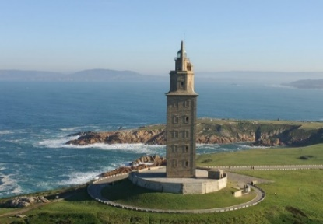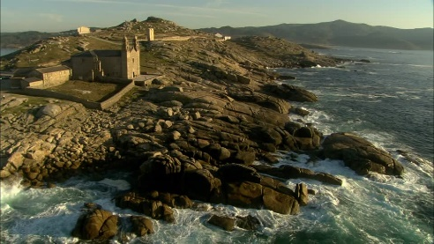
Tuesday 23rd May – We will wake and leave early so that we can be at the Sun Temple above the sacred promontory at Cape Finisterre in time for sunrise. Here we will be led in sacred ceremony and dance. We will later walk down to the hotel for coffee and croissants, and to the rocks below where pilgrims who had successfully completed their pilgrimage would traditionally burn their pilgrims’ clothes, symbolically to help earthbound souls depart. Our final journey will be from here to Santiago de Compostela. We will go to our hotel, Hotel Palacio del Carmen, and then have free time to rest or explore the city before meeting again mid-afternoon, with a guide, to visit the cathedral together. We will return to our hotel and have our last meeting together, during which we will share, remember and give thanks for our journey together. This will be followed by a celebratory dinner, during which there will be speeches and a loving-cup ceremony.
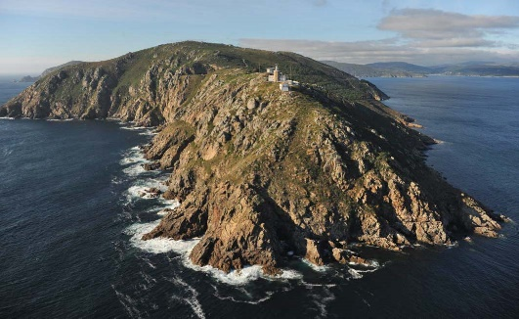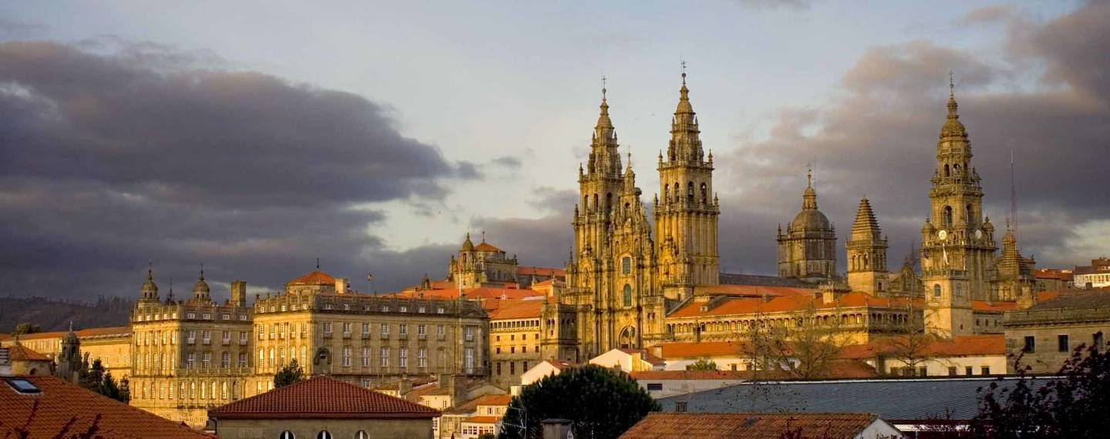
Wednesday 24th May – After Paneurhythmy and breakfast, the pilgrimage ends. Some may decide to stay on and go to the midday ‘Pilgrims Mass’ at the cathedral. Santiago de Compostela airport is a 20-minute taxi-ride from our hotel.
[The organisers reserve the right to adjust or amend the programme if necessary.]

Travel suggestions
- The Hotel Ercilla Lopez de Haro in Bilbao is 20-25 minutes by taxi from Bilbao airport.
- There are flights to many European destinations from Santiago de Compostela.

Cost
Double Occupancy £1,530 per person
Single Occupancy £2,070 per person
Cost includes all hotels (bed, breakfast and dinner), entrance fees, coach hire, organisation, teaching, leadership, guide, and most lunches (see below).
Costs exclude flights and transport to hotel in Bilbao and from hotel in Santiago de Compostela after the pilgrimage ends. Lunch in Santiago de Compostela is also excluded. Minibars, hotel pay TV, laundry, hotel phone, and all drinks are at your own cost.
Further Information & Booking
Email: sarah@zoence.com or jtod@29br.co.uk

Outline Programme and Itinerary
Tuesday 16th May (earth day)
15.00 to 18.00 - pilgrims arrive in Bilbao and stay at the Hotel Ercilla Lopez de Haro, which is in the centre of Bilbao
18.30 – welcome meeting (1 hour) – come dressed for dinner
19.30 – dinner
Wednesday 17th May (water day)
0830 – 09.30 – breakfast
10.00 – 12.30 – Peter and Sarah shall set the framework for the pilgrimage – followed by lunch
14.00 – All the main attractions are within walking distance of the hotel. We will first visit the Guggenheim Museum [20 mins walk].
16.15 – We will walk from the Museum around the south bank of the River Nervion and cross into the Old Quarter where we will visit St James Cathedral [the cathedral does not open until 5pm in the afternoon].
17.00 – Dedications at the Cathedral
17.45 – walk back to the hotel together
18.30 – 19.30 – Talk by Peter and Sarah on pilgrimage skills
20.00 Dinner and overnight at the Hotel Ercilla Lopez de Haro. (suggest pack as early departure the next day)
Thursday 18th May (air day)
07.15 – Paneurhythmy (for those that want)
07.45 – 08.45 – Breakfast [keep hats/ water and sun cream/ notebooks separate from luggage as will be needed during the day]
09.00 – leave hotel promptly and travel to Burgos [we will have this coach for the remainder of the journey].
11.00 – visit Burgos Cathedral, and after lunch together in Burgos.
14.30 - leave Burgos and visit the templar church at Castrojeriz
16.15 – coach on to Leon
18.15 – arrive in Leon – dinner and overnight at the NH Collection Plaza Mayor Hotel in the main square in the centre of the old town
Friday 19th May (fire day)
07.30 – Paneurhythmy
08.30 – breakfast in hotel
09.30 – walk together to Leon Cathedral and after to Plaza Major. Followed by coffee in a traditional street in the old town.
12.30 – Coach to Astorga and late lunch in traditional local restaurant
15.00 – visit Astorga Cathedral
17.00 – go to hotel in Astorga
19.30 – dinner and overnight in Hotel Spa Via de la Plata, Astorga
21.00 – meeting and sharing after dinner

Saturday 20th May (earth day)
0730 – Paneurhythmy
08.15- 09.15 – breakfast in hotel
09.30 – coach to ancient and sacred mound ‘El Cruz e Ferro’
10.30 – coach on to Ponferrada – visit the Basilica dedicated to the Virgin Mary before lunch
13.00 – lunch in outdoor restaurant next to the Templar Castle walls.
14.30 – visit Templar Castle
17.00 – coach to hotel in Ponferrada
19.30 – dinner and overnight at the Hotel Ponferrada
21.00 – meeting/sharing
Sunday 21st May (water day)
07.30 – Paneurhythmy
08.15 – 09.00 – breakfast in hotel
09.00 – coach to ‘Gateway to Forgiveness’ in Villafranca del Bierzo
10.00 – coach to Lugo [the higher crown chakra of the central pillar]
11.30 – arrive in Lugo and visit the famous walls of this cathedral city
13.00 – lunch in Lugo and time in the early afternoon to explore and to walk around some of the ancient city walls.
17.00 – Coach to Santa Cruz (on northern coast of Spain)
19.30 – drinks on the terrace with views out over the Bay and dinner and overnight in hotel – Noa Boutique Hotel
21.00 – meeting/sharing
Monday 22nd May (air day)
0730 – Paneurhythmy
08.00 – 09.00 – breakfast
09.00 – leave by coach to A Coruna (20 minutes) – visit the Tower of Hercules.
11.00 – coach to Muxia and early lunch near Muxia (house speciality ‘Paella’)
14.00 – visit the sanctuary in Muxia and the magic rocks.
15.30 – coach to Cee (on the coast) and go straight to the hotel [45 minutes]
19.30 – dinner in hotel (suggest early night as dawn start for ceremony in Finisterre the next day)
Tuesday 23rd May (fire day)
06.15 – leave the hotel promptly so that we can be at the Sun Temple in Cape Finisterre in time for sunrise
07.15 – sunrise at the Sun Temple – Peter and Sarah will lead a ceremony
09.00 – coffee/ orange juice/ croissants (loo stop) at O Semaforo de Fisterra Hotel – terrace high up above the rocks of Cape Finisterre below. spend some time on the rocks.
10.30 – coach to our hotel in Santiago de Compostela.
12.00 – arrive at the hotel, Hotel Palacio del Carmen. Time to rest/ lunch/ explore Santiago de Compostela (lunch at Pilgrim’s own expense)
15.30 – meet at the Praza do Obradoira on the north side of the Cathedral – this is the main square and is where pilgrims congregate to celebrate the end of their pilgrimage and prepare to enter the cathedral.
We will have a guide who will take us into the cathedral. We will arrange time in the cathedral for a group attunement.
18.30 – last meeting/ sharing/ remembering and thanking in hotel
20.00 - Celebratory dinner in hotel (Love Feast)
Wednesday 24th May
07.30 – Paneurhythmy
08.30 – breakfast in the hotel
Pilgrimage ends
Santiago de Compostela airport is 25 mins in a taxi from the hotel – some may wish to go the Pilgrims Mass in the Cathedral which is at midday every day.

