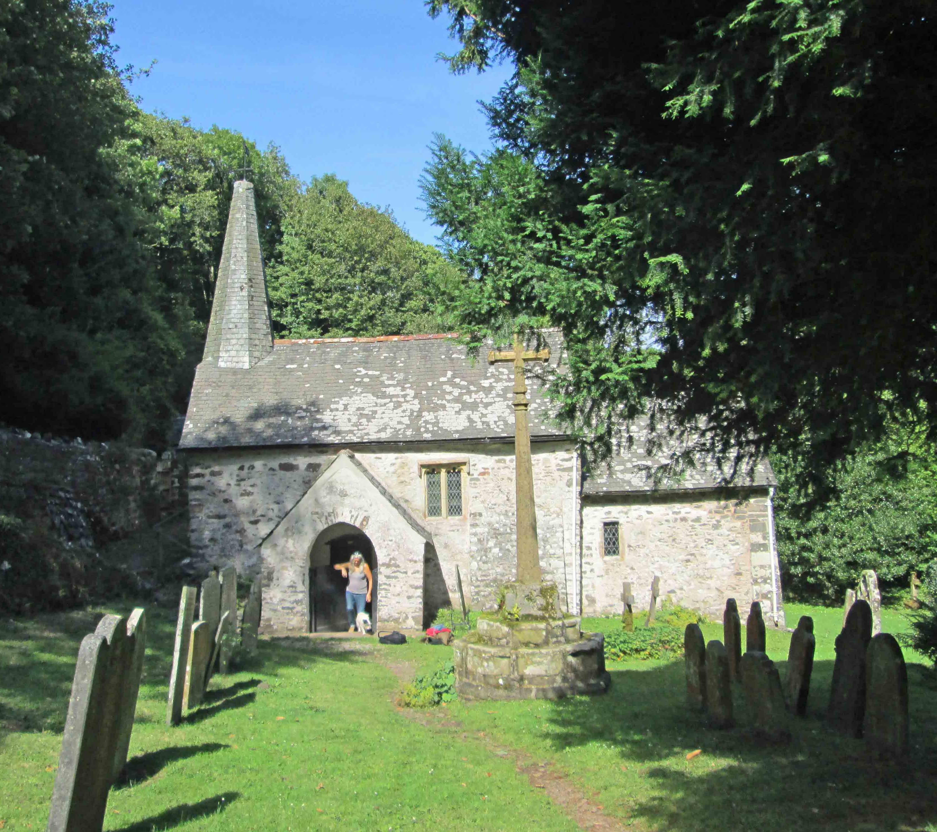
PLACES OF TRUTH—
a day pilgrimage to Culbone
with meditation, writing
& convivial company
~
A Gatekeeper Trust day with Jay Ramsay, poet,
following in the footsteps of
Samuel Taylor Coleridge

‘But oh ! that deep romantic chasm which slanted
Down the green hill athwart a cedarn cover!
A savage place ! as holy and enchanted

As e’er beneath a waning moon was haunted

By woman wailing for her demon lover !

—Kubla Khan
~
10am for 10.30am, 7th October 2017
Meet at Culbone Inn car park (on A39 past Minehead)
~
A walk to the magical hanging valley of Culbone with its diminutive church and a further wooded descent on down to the sea at Porlock Weir.
There will be opportunities to capture the moment in poetry in the company of the highly acclaimed poet Jay Ramsay, author of many books of poetry.*
We will pause at the church for the nourishment of soul and body.
~
Price £15 for the day
(does not include lunch or other expenses such as transport)
Accommodation is available at Pepperhill Barn, Over Stowey, TA5 1HL
including supper on Friday and transport to Culbone.
~
Bring good footwear for walking in, and a picnic lunch to share. Be aware that the walks are fairly lengthy, will require medium fitness and can be steep in places.
~
Please contact: Lucy Wyatt (LucyWyatt57@gmail.com) if you would like to come to this special day and if you would like to stay at Pepperhill Barn
~
*Jay’s latest collections are “Diamond Cutters–Visionary Poets in America, Britain & Oceania” (co-edited with Andrew Harvey, Tayen Lane, San Francisco, 2016) and “Dreams Down Under—celebrating Australia” (knives forks & spoons, 2017). His “Places of Truth”, which includes the sequence about Culbone, is available from www.awenpublications.co.uk

